## C:\Users\llim\OneDrive for Business\ADMIN_Reports\Templates\Accela_Logo_2inch.png

# AD HOC REPORTING > **Filters** tab

# Filter Logic

* When multiple filters are added in the **Filters** tab, **by default** Ad Hoc Reporting uses “AND” logic to apply all filters. This means that for a record to appear in the report, ALL of the filters must be True for the record.
* The **Filter Logic** field allows you to use “OR” logic with one or more filters.
* For detailed information about the SQL logical operators “AND”, “OR”, see <http://www.praetoriate.com/t_garmany_easysql_sql_logical_operators.htm>

### Example 1:

* + Using the Filters in the screenshot below, the resulting report must only show records whose Module is “Building” AND whose Record Type is “New Commercial Building” AND whose Status is “Application Received” AND whose Status is “Application Approved”.   
    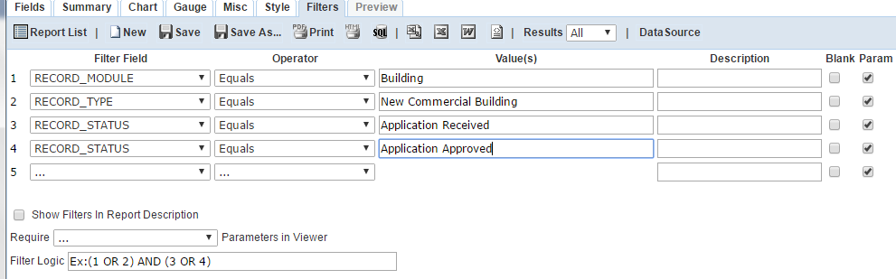

*(Note that the* ***Filter Logic*** *field wasn’t edited; its default value begins with “****Ex****:”, which means the Filter Logic is an* ***Ex****ample and is ignored.)*

* + However, since it isn’t possible for a record’s Status to be **BOTH** “Application Received” **AND** “Application Approved”, the report output will ALWAYS be empty.
  + We want to find records whose Status is **EITHER** “Application Received” **OR** “Application Approved”. To do so, edit the **Filter Logic** field so that it contains: **1 AND 2 AND (3 OR 4):**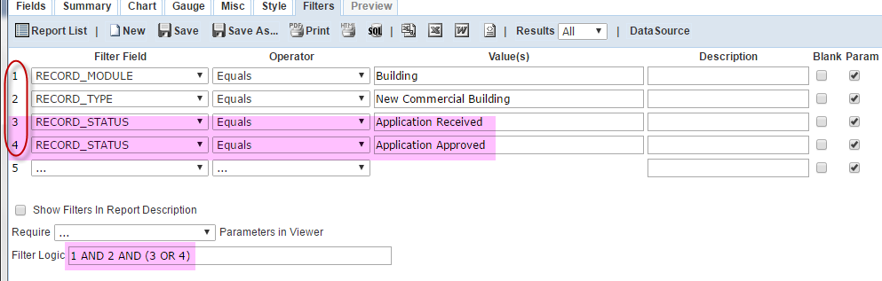
  + Understanding the contents of the **Filter Logic** field:
    - **1, 2, 3, 4**: These refer to filters above it, where each filter is referenced by a number (circled in red in the screenshot above)
    - **1 AND 2 AND (3 OR 4)** means: Find all records whose Module is “Building” AND whose Record Type is “New Commercial Building” AND whose Status is “Application Received” OR “Application Approved”.
    - Adding the parentheses **( )** around **3 OR 4** is very important, due to the rules of AND and OR precedence. Adding the parentheses ensures filters 3 and 4 are evaluated together.

### Example 2: Find records where a field matches one of a list of values

Report must find records whose Record Type is “New Single Family Residence”, “New Multi-Family Residence”, or “New Residential Duplex”. The Record must also belong to the “Building” module and was opened on the parameter Date.

* + Set up the **Filters** like this:

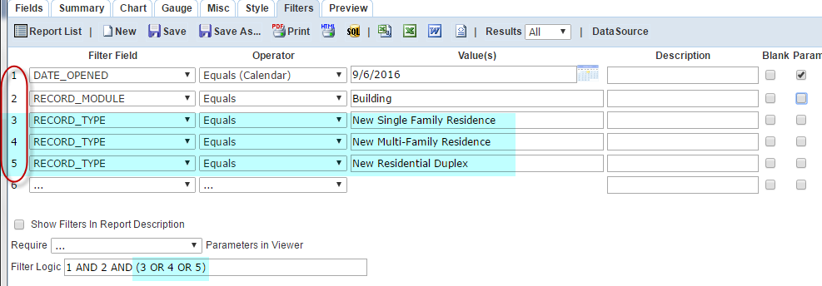

* + Enter this in the **Filter Logic** field: **1 AND 2 AND (3 OR 4 OR 5)**
  + Understanding the contents of the **Filter Logic** field:
    - **1, 2, 3, 4, 5**: These refer to filters above it, where each filter is referenced by a number (circled in red in the screenshot above)
    - **1 AND 2 AND (3 OR 4 OR 5)** means: Find all records whose DATE\_OPENED is 9/6/2016 **AND** whose RECORD\_MODULE is “Building” **AND** whose RECORD\_TYPE is “New Single Family Residence” **OR** “New Multi-Family Residence” **OR** “New Residential Duplex”.
  + Adding the parentheses **( )** around **3 OR 4 OR 5** is very important, due to the rules of AND and OR precedence. Adding the parentheses ensures filters 3, 4 and 5 are evaluated together.